Makin’ the Makeline – Sensors, Pizza Locker

ECE4873 Senior Design Project

The Neatest ECE Team
Dr. Xiaoli Ma
Papa John's International

Annie Liu | Damian Huerta | David Wechsler | Dennis Crawford | Leah Jackson
CmpE | CmpE | EE | CmpE | EE
aliu321 | dhuertaortega3 | dwechsler6 | dcrawford41 | ljackson74
aliu321@gatech.edu | damhue039@gatech.edu | davidwechsler@gatech.edu | dennis.crawford@gatech.edu | ljackson74@gatech.edu

Submission Date: 2/11/22
Table of Contents

Executive Summary (5 pts) ii

- Introduction (10 pts) 1

  - Objective xx
  - Motivation xx
  - Background xx

- Project Description and Goals (15 pts) xx

- Technical Specification (15 pts) xx

- Design Approach and Details (20 pts)

  - Design Approach xx
  - Codes and Standards xx
  - Constraints, Alternatives, and Tradeoffs xx

- Schedule, Tasks, and Milestones (10 pts) xx

- Project Demonstration (5 pts) xx

- Marketing and Cost Analysis (5 pts) xx

  - Marketing Analysis xx
  - Cost Analysis xx

- Current Status (5 pts) xx

- Leadership Roles (5 pts) xx

- References (5 pts) xx

Appendix A xx

Appendix B xx
Executive Summary
Our main objective for this project is to design a product that allows customers to efficiently pick up pizza whenever they want. Workers in Papa Johns have trouble getting people in and out of the store within 3 minutes. On average, it takes between 7-8 minutes. In order to allow customers to have a faster and better experience with ordering their pizza, we proposed heated lockers that are connected to an application. This application will allow customers to order their pizza, then retrieve a QR code that will act as a key to opening a locker to their fresh pizza. Our performance goal is to have customers in and out of the store in less time. This is similar to Amazon Hub Lockers, where buyers are notified when their package has arrived, and they are sent a bar code to pick up their package. Workers in the back load the package within a few minutes of the buyer's arrival so that they are in and out within a few minutes. Our budget for the product is 1,000 dollars. Some of our future work may include building more sustainable lockers.
Makin’ the Makeline – Sensors, Pizza Locker
1. Introduction
Over the past week, our team has visited multiple Papa John's locations in Atlanta. A common occurrence across multiple stores was the staff's desire to better optimize its pickup order system. At one location, it was mentioned that the employees aim to decrease customer time in the store from 6 minutes to less than 3 minutes – a reduction of 50%. Given this scenario, our team has decided that the use of an automated system could vastly help Papa John's reach this goal.
In order minimize customers' waiting times when picking up orders at Papa John's, the Neatest ECE Team proposes the adoption of a locker device to enable instant and autonomous collection of an order by the customer. Similarly, the creation and development of a smartphone application to coordinate such lockers is also within the scope of this project. As shown in Section 7 of this document – entitled Marketing and Cost Analysis –, the total cost and funding requested is approximated $910. A detailed breakdown of each design cost is also available.
The intended user of the proposed locker are customers picking up pizza orders in-store. The locker will contain several trays that will keep the pizza warm, which can only be unlocked by their corresponding customers. This will require an integration between the locker and the app downloaded on the customer’s smartphone device. This document provides an in-depth analysis of the project proposed, including customer requirements, technical specifications, design approach, project schedule, cost analysis, and more.
The Neatest ECE Team is committed to diversity of thought, determination, and effort. This project will be guided by those principles. We are devoted to delivering a project that will help both Papa John’s International as its customers by improving the overall pizza pickup experience. We understand the difficulty of this task and anticipate challenges such as limitations on technology given our budget constraints. However, we firmly believe that abiding by our core values will facilitate us to meet our end goals.

2. Project Description, Customer Requirements, and Goals
The team will be designing a locker and application that enables customers to directly access their order in a fast and efficient manner. This locker will have a scanner, where the customers will have to scan a unique barcode/QRcode that they will retrieve once they are done ordering through the application. Once this code is scanned, the locker is opened, and the customer can retrieve their pizza. The order will contain information such as approximately what time their pizza will be ready and notify you when your pizza is hot and ready to be picked up in the locker.
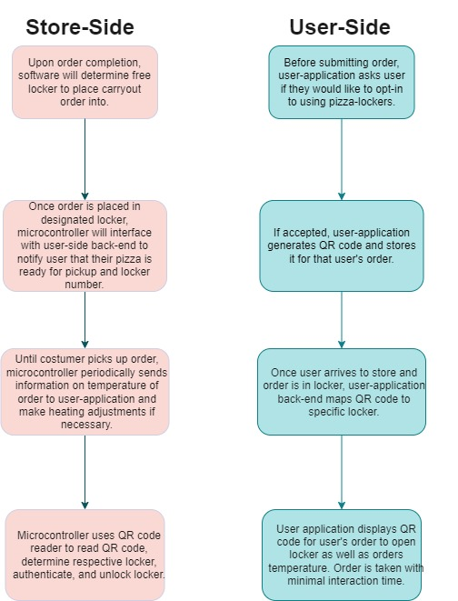
Figure 1. User-Side & Store-Side flow char of locker/app functionality

Customers who are frequent pizza consumers and who enjoy a convenient way of accessing fresh pizza will be using this product. Customer needs for this project includes a free highly assessable application that is easy to use and straight forward. The application and locker access should be free and tell you at what location to pick up your pizza. At a typical Papa Johns, it is ideal for customers to be in and out within 3 minutes, however, because of many delays the process usually takes 7 to 8 mins. Our goal for this project is to have customers in and out in less time. The targeted price for the product will be close to $1000.
Fig
The design of the locker should allow the pizza to continually stay warm at a consistent temperature from 140 degrees Fahrenheit to 150 degrees Fahrenheit. To ensure quality of ingredients, once a pizza is in a locker, the customer will be given 40 minutes to retrieve their pizza before a worker takes it back.

Keep Satisfied  - Pizza Customers  - Corporations | Manage Closely  - Store workers  - Managers
Monitor (Minimal Effort)  - Help Desk  - Engineers | Keep informed  - Marketing
Figure 2. Stake Holders Chart

Some of the constraints that we may have are getting hold of high-quality hardware components such as a temperature sensor that measures the temperature of the locker accurately. We also may have trouble getting high quality material for the locker because of our budget.
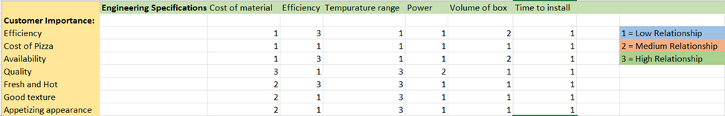
Figure 3. QFD chart for Customer Importance and Engineering Specifications

- Technical Specifications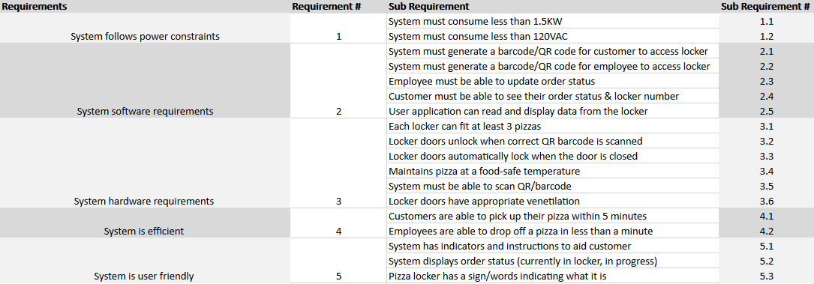
- Design Approach and Details
Our design approach can be broken up into three sub-categories: the physical lockers, micro controller to control the locker, and the user application. The physical lockers will be designed with the minimization of heat dissipation in mind to ensure a pizza that is ready for pickup can remain at an appropriate temperature. We will approach this by having some insulating material lining each locker as well as exploring infrared bulbs to aid in the heating process of heated food such as pizzas, breadsticks, and desserts. The last piece of major hardware in this category would be temperature sensors to periodically update the temperature data on the user-application. In order for us to create a modern device, we will have a need for a microcontroller sub-system that will interface with the back end of our user application. This sub-system will oversee the locker’s side of authentication and opening a specified locker based on a QR code, providing data to the user application about pizza temperature, and the physical locking/unlocking of each locker. The current micro-controller we are exploring that could handle this would be a Raspberry Pi 4. For the application aspect of this project, we need an application that is account based, which can be used from either a customer standpoint or employee standpoint. An employee needs to be able to update order status and access lockers, while a customer needs to be able to see information regarding order status, pizza temperature, and authentication information through use of QR codes that allows them to scan at the locker and retrieve appropriate order.
  - Design Concept Ideation, Constraints, Alternatives, and Tradeoffs
This section will look at the functions the design needs to fulfil and potential solutions to each. Below is a list of fundamental functions that the design must fulfil according to our current specifications. They will be broken up into our three main sub-categories listed above.
- Physical Locker
  - The physical locker must maintain the pizza temperature between 150 – 200 Fahrenheit. This temperature is subject to change based on further testing of ideal pizza temperature within a cardboard box.
  - Each locker must have some sort of ventilation to ensure appropriate moisture is maintained so that the food does not dry up or become soggy. Further specification on this will be collected via experiments.
  - Each locker must be able to fit a reasonable order size of 2-5 pizzas or have varying sizes for different sized orders. This size can be obtained by viewing data of the average pizza order as well as the dimension of pizza boxes, breadstick boxes, and dessert containers.
  - There should be no access available to an individual locker unless you are the end consumer or an employee placing the order into the locker.
  - The Physical locker must be able to be powered by a regular 120V 15A outlet.
- Micro-controller
  - Our micro controller must be able to interface with some user interface to provide UI and make order pickup as simple as possible.
  - The micro controller must be able to communicate via the web to our user-application back end to send/receive data.
  - The micro controller must be able to interface with hardware such as a temperature sensor, locking mechanism (solenoid), potential infrared lighting system, and QR code reader. The main reasoning behind using a QR code for authentication is to have a unique QR code per transaction. Furthermore, in the times of COVID-19, we can use QR-code readers to have contact-less transactions that could not be possible with a PIN code.
- User application
  - The application must be able to read and display data from the actual locker unit to the end user (information from microcontroller), such as temperature, status of order, locker number to retrieve order from.
  - The application must be able to be used from a customer perspective and employee perspective to store/retrieve pizza in lockers.
The table below displays the specific design approach to achieve the sub-functions described above.
Sub-Function | Design Approach
1.a | Different combination of materials for the interior of lockers can be analyzed by looking at their heat curves. A combination that maximizes cost efficacy, power balance of infrared heating system, and ideal temperature will lead to selecting best material for interior. If budget allows, experiments can be executed to find optimal interior material.
1.b | This sub-function will be achieved by having some sort of ventilation system incorporating humidity control, fan system with intake and exhaust, and potential moisture sensors inside lockers along with experiments to find optimal combinations and fan curves.
1.c | The individuals in charge of the construction of the physical lockers will take precise measurements of boxes for pizzas, breadsticks, and desserts. This data will be used to come up with locker sizes that would allow for various order combinations. Potentially segmenting the lockers so there are ones for small, medium, and large orders without compromising other functions. Papa Johns has four sized pizzas: small, medium, large, and extra-large being of size 10 in, 12 in, 14 in, and 16 in respectively. Each pizza box is about 1/8 of an inch bigger than the respective pizza and 1.75 inches tall. In addition, most sides are placed in either 10 inches or 12-inch boxes. An average order of 2 large pizzas with one side should be able to fit in a locker of size 16in x 16in x 10 in should fit this plentiful and other order combinations. The next approach would be to look at the varying order sizes to determine other locker sizes.
1.d | Attaining the authentication functionality will be an interaction between all sub systems to read the QR code, check with the user application, unlock the locker via the micro controller, and ensuring the physical locker cannot open to any user. In addition, the locker will implement a physical key-locking mechanism to access in case power is not available.
1.e | This sub function will be achievable simply by selecting electrical parts that do not exceed these power specifications. This should not be much of a struggle since the electronics we are using use minimal power in comparison.
2.a | Since we have chosen a Raspberry Pi 4, this micro controller provides an HDMI connection that can be used to interface with the display. In addition, the programming language used on the micro-controller will likely be python due to the ease in coding and vast libraries such as PyParadigm. Furthermore, a touch screen display will likely be used to increase user experience such as the one listed here.
2.b | The Raspberry Pi 4 has an ethernet port and has models that can connect via Wi-Fi. Again, since we are using python, there are extensive libraries to communicate over the web, and setting up a REST API will allow the desired communication between application and microcontroller.
2.c | The selection of our micro-controller was critical in being able to interface with all sensors and electronics. With the Raspberry Pi 4, there is the traditional PI headers with various GPIO pins that can be hooked up and treated as digital IO pins to activate/regulate/communicate with various sensors created specifically to function with our micro-controller.
3.a | The application would require a user profile in order to expose customer/employee specific information to an API for required information that needs to be displayed, such as list of orders from an employee perspective or pizza status from customer perspective.
3.b | The application will have to receive a QR code that can be used by the locker to verify status as customer/employee and open locker appropriately. As an employee account, the application would open an unused locker after scanning a code that is generated for the employee when a user submits an order, and from a user perspective, they would need to receive a QR code that is generated once their order is placed in a locker that contains information about the appropriate locker.

Within each of these design approaches there were various trade-offs to consider which will be discussed below.
- Selecting to incorporate some sort of ventilation system does complicate the design of the code running on the micro-controller but adds more control to the quality of each consumable. In addition, further power will be consumed that needs to be considered. However, we deem that the trade-off is worth the improvement of the conditions where the pizza will be.
- The design of different size lockers poses an issue of potentially underutilizing space that could be used for a larger number of small orders. This decision is very much still up for grabs based on data of the average order or procedures to be used for orders too large to fit in the lockers. There is room for having the ability to use our locker for a wider range of orders with different sized lockers that could be worth it depending on the variation of order sizes on a regular basis. This could be especially useful for high-traffic times.
- One very simple trade off to consider is the authentication method to use to access one’s order. Utilizing a pin is a very viable option with simplicity but could hinder the user experience. There are simpler options that have adequate security for our design, such as using QR codes to unlock the lockers. Although this will add some complexity to the user application and micro-controller software, it improves the user experience with added ease and less time used inputting a pin. In addition, transferring a QR code from one phone to another is very simple and can have more uniqueness compared to say a 4-digit code. Once again, we refrain from more complex authentication methods due to the relatively low value of pizza.
- The final big trade-off we have faced so far is the selection of a micro-controller. There are infinite possibilities such as using an ARM mbed. Although there are various libraries housed on their online compiler, this microcontroller would limit our compute power that we wish to have. In addition, there would be limited screen options available to achieve our desired user interface. There are multiple other microcontrollers that have tradeoffs between price, computing power, IO ports, etc. We chose to use a Raspberry Pie since it has adequate computing power, display functionality, various GPIO ports with a reasonable price increase. Furthermore, another trade off to consider is the programming languages supported by these micro controllers. The ARM mbed supports C style programming which can run very efficiently but lacks some abstractions and high-level libraries that would make programming for our design a lot easier. On the contrary, the Raspberry Pie can run multiple programming languages such as python which has high level libraries with a wider range of displays. Although python programming can be orders of magnitudes slower, it will not make much of a difference in our scenario and is a worthwhile trade-off. [4]

Similarly, there are other factors that can contribute to any design such as economic, cultural, sustainability, and environmental factors. The table below will look at some of the factors that could affect our design.
Factor | Affect
Sustainability | Ensuring that we create a sustainable design is imperative to the ethical standards of engineering. This factor can be echoed in selecting sustainable materials that can ensure longevity of our design. A great example of this is selecting a metal chassis for our pizza lockers. This can easily result in a more sustainable design without producing excess weight. Furthermore, creating a design that is modular is very important. This can ease the maintenance of our design so that smaller components can be very easily replaced. We also chose to go with electronic components that are actively manufactured to ensure replacements are easy to obtain.
Economic | Since our design is targeted at the pizza market, we would like the implementation of our design to not have economic effects on the price of the pizzas. Our design should only enhance the user experience and hopefully increase traffic. We would like to eliminate hesitation of ordering due to fear of time spent picking up a pizza or online ordering process. Therefore, we wish to have our budget reflect that and a sustainable design also ensures we have little to no impact on the economics of pizza making.
Environmental | As explained in the sustainability portion, we chose parts that would result in ease of maintenance and try to minimize the environmental footprint by being able to reuse as much of our design if a single component breaks.
  - Preliminary Concept Selection and Justification
After we visited a Papa John's site, we saw that there was a problem with wait time, where customers had to wait longer than what the store wanted. Also, because there was no clear-cut way for workers to communicate with each other, there was a slight delay in the overall process. In order to allow customers to get a better experience, we thought lockers would allow customers to pick up their food within a certain timeframe with the pizza still hot.
The technical critical path that we may have is making sure the application works together with the physical locker. In order to assure that we overcome this critical path, we will have to test the application continuously to make sure that it works with the hardware. Another critical path is making sure the locker stays hot. In order to achieve this, we will have to find the right material that will keep the pizza at an optimal temperature.
Some known aspects of our project design is using a QR code/barcode as a key to open the lockers. Some potential risks for this project is making sure that the pizza remains hot at a specific temperature for a long period of time. We might have to test with different material to find the optimal design that will work the best.
For our final design we will have a working product that allows people open a heated locker through a QR code.
  - Engineering Analyses and Experiment
Since we have three main sub-systems in our design, we will take at potential test plans for each.
- Physical Locker
  - Experiments can be designed to place pizza inside our proto-type and simulating user wait times while monitoring the temperature inside for a given order to test the insulation qualities, temperature sensors, and ventilation system.
  - A structural test will be performed to ensure that an average individual cannot access a physical locker by force. This will be a demo-type of test.
  - The final test we plan to perform is trying to fit various, common orders into physical lockers to ensure that the selected locker size is satisfactory to fit as many order combinations as possible.
- Microcontroller
  - The first test to be performed for our microcontroller subsystem would be to ensure that our software state machine works as intended. Various demos can be setup to ensure that once a QR code is generated it can be read via our QR code reader and be recognized. This test would provide confidence that we can perform authentication.
  - Another test for our microcontrollers can be to test each individual external hardware component such as temperature sensors, locking mechanism, and screen. This will be a recurring test that can be used every time a new feature is implemented for our microcontroller code. This can range from reading and displaying temperature, locking/unlocking mechanism, displaying to the screen, etc.
  - The final main test to be performed will be testing the network connection between the Raspberry Pi and our user application back-end. This can be done via incremental demos passing data such as temperature, unlocking, QR codes, and general communication of when a pizza has been placed in a respective locker
- User Application
  - The first test for the user application will be that the user interface properly displays data, meaning that proper formatting of data or QR codes should be clearly visible, and can be demonstrated with dummy data.
  - Another test for the user application will be to demonstrate that it can reliably send/receive data from the microcontroller subsystem, which will be verified by posting API information through the app, that the microcontroller then receives, and the microcontroller generates a response that can then be posted to the API and received by the application.
  - A third test for the user application is that accounts must be attributed to either a customer account or employee account, with the privileges and layout of the app being dependent on the account type. This test can be verified by creating both a user account and an employee account, where an employee account should be able to view a list of orders and scan codes associated with the orders to interface with the locker setup, and a customer account should be able to view their order status and pizza temperature, and when their order is completed, view a QR code to scan to retrieve their pizza.

  - Codes and Standards
Standard Body | Description | Impact
NFPA | Standards relating to  heat producing appliances [5] | Heating apparatus/ power supply needs  to follow the fire safety  guidelines.
IEEE | Standards relating to electronics usage [6] and network traffic usage [7] | Need to follow rules regarding network traffic for application design and use of sensors in our product.
OSHA | Standards relating to workplace  safety/health [8] | Need to make sure our locker design does not break any workplace safety requirements based on footprint or heating safety.
FDA | Standards relating to proper storage and handling of food [9] | Need to make sure our locker is up to code relating to safety of food storage.
- Project Demonstration
The project will be demonstrated with a simple demonstration of individuals having some sort of a simulated order from Papa Johns and using our pizza lockers as their carry-out method. We will attempt to have multiple “customers” perform this and collect data from a survey afterwards about the satisfaction level of using our design. Each survey can ask for data on satisfaction of pizza temperature/freshness, accuracy of prep-time estimation, ease of access, user friendliness of our application and UI, and willingness to order again using our device. We hope to obtain positive feedback from our volunteers to prove the increased user experience at Papa Johns. Another critical issue we learned from visiting Papa John’s was that they would like to have customers carry out interactions be around 3 minutes but are currently in the range of 3-7 minutes. We hope to run some tests with various traffic to see the decrease in interaction time by automating the carry out process. It may be hard to get it to an exact 3 minutes or to quantify that, so our main goal is to look at the data provided and attempt to run experiments that yield a shorter average interaction time at Papa John’s locations using our pizza locker.
In addition, the use of our design will prove the functionality of our design. Specifically, utilizing our user app to obtain a QR-code and using that to unlock a designated pizza locker. This would be a proof-of-concept demo to ensure we have achieved our specification. There are many variables that can be manipulated in each demo such as order size, varying prep time for the pizzas, different temperatures, etc. These demos can be used to fine-tune these parameters in a matter that can maximize customer satisfaction.
- Schedule, Tasks, and Milestones: 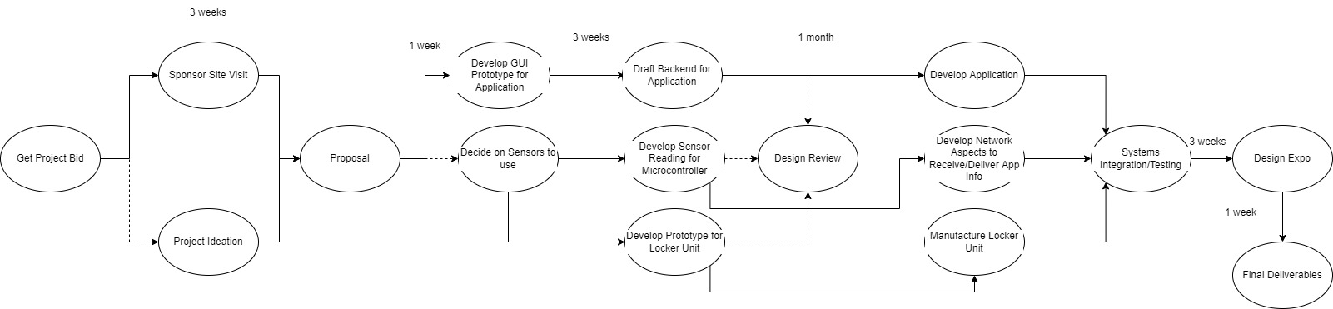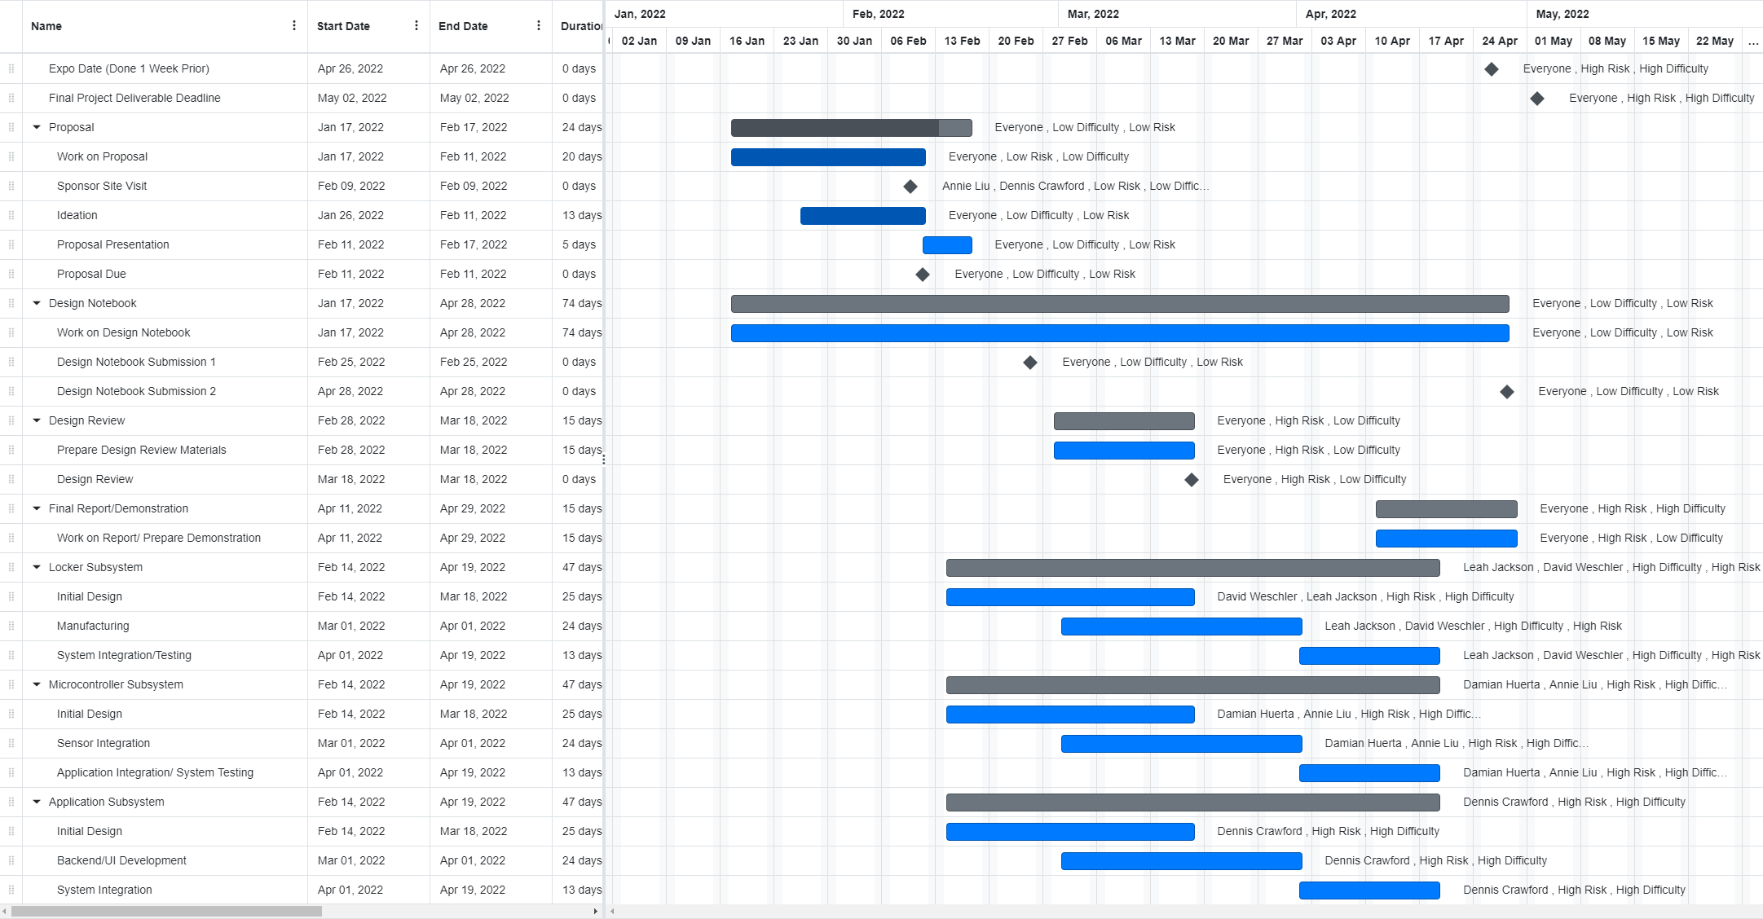
- Marketing and Cost Analysis
  - Cost Analysis
Supplies:
Pizza Warmer (1) | $500 [1]
QR/Barcode Scanner (1) | $50 [2]
5” Monitor (1) | $70 [3]
Raspberry Pi (1) | $45 [4]
Computer controllable latches (3) | $100
Wood to build stand for the system | $100
Paint | $30
Sticker vinyl | $15
Total | $910

Design Labor Costs
Assuming that the average starting salary for an engineer is $75,000, this results in an hourly salary of $38/hr. The average course at Georgia Tech that is three credit hours requires nine hours of weekly time, and six of those hours are spent outside of class, which we will consider the billable hours of the project. There are 13 weeks, out of the 16 total in a semester, that this team of five engineers will each spend six hours on the project. This results in a total labor cost of $14,820.
$$\frac{38}{hr ⋅engineer}⋅\frac{6 hr}{week}⋅\frac{13 weeks}{semester}⋅5 engineers = 14,820$$
Total Cost
“n” indicates that this is a cost per pizza locker
Supplies | $910n
Design Labor | $14820
Assembly | $160(n-1)
Delivery | $200n

The reoccurring cost per pizza locker is the cost to assemble, supplies, and delivery fees. Assuming that after the initial design plans are made it takes a moderately skilled worker, paid $20/hr., one workday to assemble a pizza locker, this costs $160 for assembly. In the table above, it is assumed that the first pizza locker is assembled by the engineering design team. Delivery is hard to approximate, so for the sake of this discussion it will be approximated to $200, the cost of a day of work from someone at $20/hr, plus gas.
Overall Cost Analysis
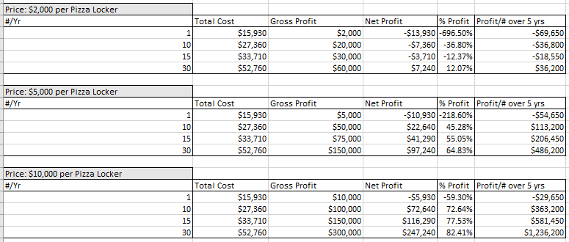
The above table analyzes three price points for our product when selling different numbers of products. The first price point, $2,000, is unreasonable because it would take selling at least 30 products a year to make a profit. According to this analysis, it would be recommended to sell the pizza locker for between $5-10,000 if 10 units can be sold per year.
- Current Status
We have had four meetings with our advisor, Dr. Ma. We have met with our project sponsor from Papa John’s, Justin Falciola, and have visited the Georgia Tech Papa John’s location. We are currently in contact with the mechanical engineering team that is also working on a Papa John’s capstone project.
From our visit to the Papa John’s store, we further refined our project idea from automatic temperature measurement of ingredients on the pizza topping bar to a pizza locker from feedback from employees and observation of the work environment.
- Leadership Roles
- Sponsor Liaison: Annie Liu
- Financial Manager: Damian Huerta-Ortega
- Expo Coordinator: David Wechsler
- Web Master: Dennis Crawford
- Team Lead: Leah Jackson

- References
Price estimates in the cost analysis:
[1] Pizza Warmer: https://www.amazon.com/HeatMax-202024-Raising-Warmer-Display/dp/B084HLQNTD
[2] QR/Barcode Reader: https://www.amazon.com/Hands-Free-Omnidirectional-Automatic-Adjustable-Supermarket/dp/B098SVNVKX/ref=sr_1_10?rid=15TM0TPXWGZKI&keywords=qr%2Bcode%2Bscanner&qid=1644601943&sprefix=qr%2Bcode%2Bscanner%2Caps%2C68&sr=8-10&th=1
[3] LCD Screen: https://www.digikey.com/en/products/detail/seeed-technology-co-ltd/104990243/6025760?s=N4IgjCBcoLQBxVAYygMwIYBsDOBTANCAPZQDa4ArAJwDsIAugL6OEBMZ4ADACxVWetuAZgaMgA
[4] Raspberry Pi: https://www.raspberrypi.com/products/raspberry-pi-4-model-b/
Codes and Standards
[5] NFPA Standards: https://www.nfpa.org/Codes-and-Standards/All-Codes-and-Standards/List-of-Codes-and-Standards
[6] IEEE Communications Standards: https://standards.ieee.org/search/?q=Communications&type=Standard
[7] IEEE Electrical Safety Standards: https://standards.ieee.org/search/?q=National%20Electrical%20Safety%20Code%20NESC&type=Standard
[8] OSHA Standards: https://www.osha.gov/laws-regs/regulations/standardnumber
[9] FDA Standards: https://www.ecfr.gov/current/title-21/part-110
Appendix
Include material that is needed to understand your report but is too lengthy to incorporate into the body of the report. Extremely lengthy information (e.g., software listings) should be posted to your project website.

